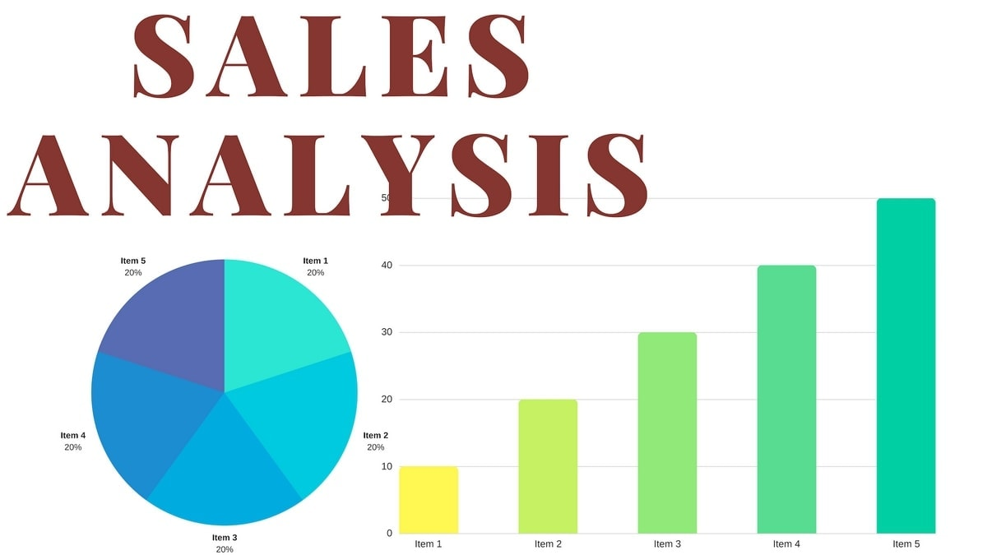

**Objective:**

The objective of this project is to analyze the e-commerce online store dataset to uncover key performance metrics and provide actionable insights to enhance store performance. The focus areas include:

* **Revenue Analysis**: Evaluate overall revenue generation and identify trends over time to understand the store's financial performance.
* **Top Product Identification**: Determine the best-selling products and their contributions to total sales to optimize inventory and marketing strategies.
* **Customer Segmentation**: Analyze customer segments based on purchasing behavior to personalize marketing efforts and improve customer retention.
* **Sales Trend Analysis**: Explore sales patterns across different timeframes, regions, and categories to identify opportunities for growth.

### **Dataset**

### **Import and Download Dataset (**[**https://github.com/dataseekho/sql-basics-beyond/tree/main/dataset**](https://github.com/dataseekho/sql-basics-beyond/tree/main/dataset)**)**

* **Dataset Structure**: The dataset includes the following tables:
  + **Orders**: Transaction IDs, Order Date, Customer ID, Product ID, Quantity, Total Amount.
  + **Products**: Product ID, Product Name, Category, Price.
  + **Customers**: Customer ID, Name, Region, Segment.
  + **Sales**: Order ID, Revenue, Discounts, Taxes.

**Methodology**:

**Data Extraction and Transformation**:

* **Use SQL** to extract, process, and transform raw transactional data into a structured and analyzable format, providing a foundation for meaningful insights.

**Data Cleaning and Analysis**:

* Utilize **Pandas** to clean and preprocess the data by handling missing values, duplicates, and inconsistencies.
* Conduct in-depth exploratory data analysis (EDA) to identify patterns, trends, and correlations that can inform business strategies.

**Sales Performance Analysis:**

* Create a comprehensive Sales Analysis Dashboard to visualize key performance indicators (KPIs), including:
  + **Revenue Trends**: Analyze revenue growth over time to track financial performance.
  + **Top-Selling Products**: Identify best-selling products and evaluate their contributions to overall sales.
  + **Customer Segmentation**: Study customer segments to understand purchasing behavior and preferences.
  + **Sales Trends**: Monitor sales patterns across various timeframes, regions, and product categories to identify growth opportunities.

**Key Findings**:

1. **Revenue Trends**

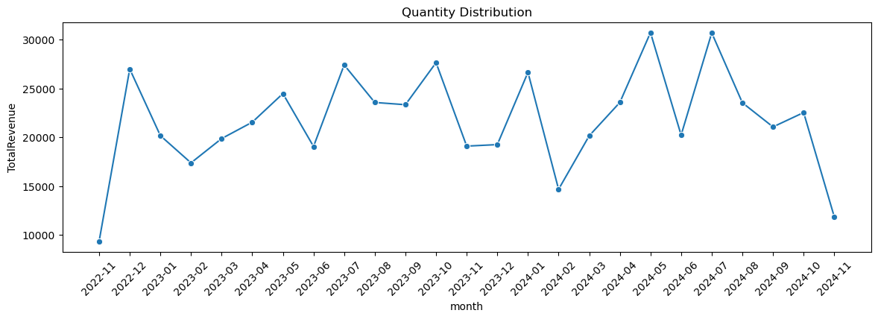

**2. Top-Selling Product**

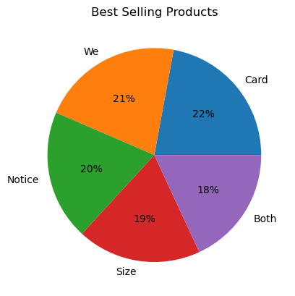

**3. Customer Segmentation**

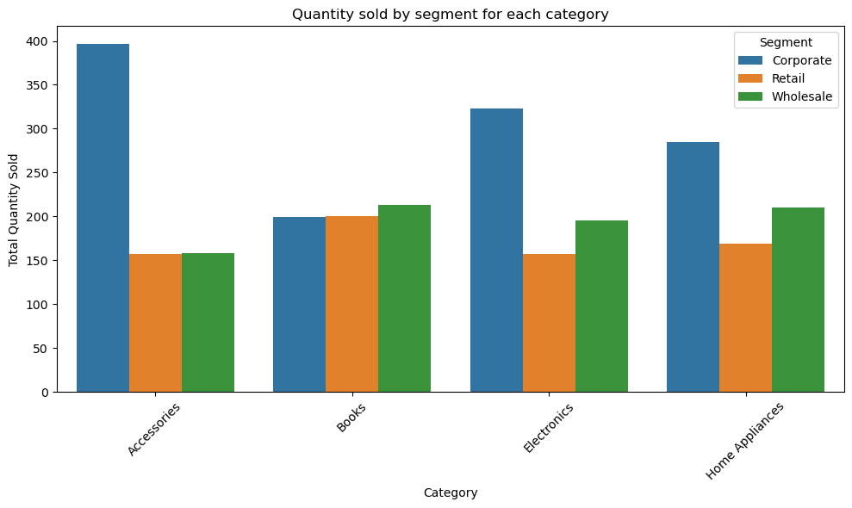

* Accessories are the preferred category for all segments but Wholesales customers show a strong preference for books.

**Sales Trends**

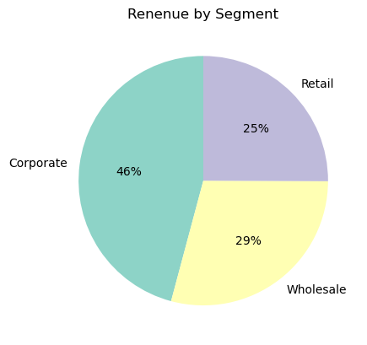

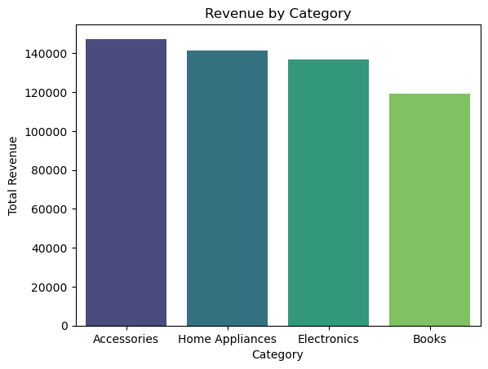

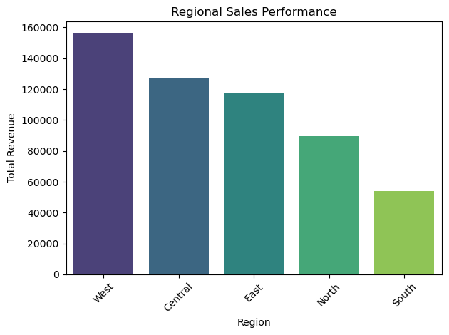

* The West region generates the highest revenue.
* Corporate customers contribute 46% of the total revenue.
* The Accessories category accounts for 27% of total revenue.

**Conclusion**

• **Top-Selling Products and Regions**: Accessories are the highest-performing product category,

With the West region contributing the most to overall sales.

• **Corporate Customers**: Corporate customers in the West region, particularly those purchasing Accessories, generate the highest revenue, highlighting this segment as a key target for future growth.

• **Customer Lifetime Value**: Customers from the West region are the most valuable in terms of lifetime spending, indicating a strong customer retention and loyalty in this region.

• **Underperforming Areas**: The South region shows lower sales in the Accessories category, suggesting a need for more focused marketing strategies, such as promotions or targeted advertising, to drive growth in this area.

• **Seasonal Trends**: July 2024 experienced the highest revenue, while November 2024 saw the lowest sales. This shows a chance to increase sales during slower months by using strategies like offering special deals or discounts.